**X.4. Registered Users**

In order for Moogle to be successful, it will need a lot of features, but the most important part of the business is to have users that are able to buy, sell, bit, and rate in the items that are being displayed on the website. Users will be able to have all the benefits of the website when they register in the website by creating an account name, providing their personal information such as phone number, email, credit card information for purchases, and some other basic information for transactions to be processed correctly and thoroughly. Next, we are interested to design a database model in which all this information would be stored and be linked to purchases where the current user has his/her information correctly extracted from the database. An ER diagram is posted below to have a better idea on how all of the information for the registered user will be linked.

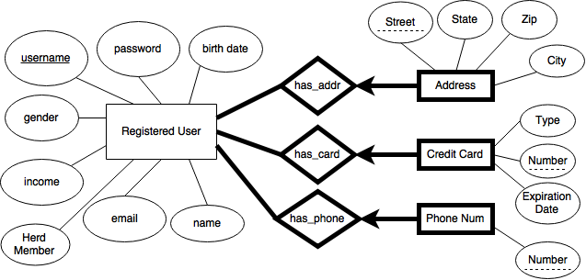

**X.9. Bidding**

We know that many websites have either sales or bidding, our goal for Moogle is for it to be versatile and incorporate both, sales and bidding. We would like to give the option to our customers not only to buy and item and perhaps be disappointed by the fact that it may be out of stock and they could not do anything about it, but also give them the opportunity to bid for an item they want and be able to bid as much as they want. Our main goal by incorporating this feature is to have a higher amount of people being registered and interested in a site that will be able to incorporate both methods of purchase. When adding this feature, there are also some restrictions in which will be placed for the bidders such as the minimum amount for a bid or that the seller cannot bid for the item he/she is selling; however, all the restriction information is not necessary in the database because all the restrictions may be checked for within the application itself. In the ER diagram posted below, we have bids as a relationship between registered users and sale items because a registered user is able to bid on an item that is for sale. The ER diagram is shown below.



**X.10. Orders and Sales Reports**

Every company needs to have reports on their orders and sales to see how sales were for the week they are looking into. Moogle will generate weekly reports on orders and sales in order to see what categories and items are customers are buying the most. In order to generate these reports, we will not need to have data stored in the database for these specifics entities, instead, we are going to take information from the Sales entity and combine it into one report since the Sales Report and Sales are very closely related; therefore, we will not be needing an ER diagram for Order or Sales Reports. Orders would have the same format, information from the Sales entity would be combined into a report that will contain what the order was and all of the information needed for the company to have an idea on what is being ordered the most.